**AUTHENTICATION & KEY AGREEMENT BASED ON ANONYMOUS IDENTITY FOR PEER-TO-PEER CLOUD**

**Abstract:**

As cloud computing continues to revolutionize data storage and resource sharing, peer-to-peer (P2P) cloud architectures have gained prominence due to their decentralized nature, scalability, and robustness. Unlike traditional cloud systems relying on centralized authorities, P2P clouds enable direct interaction and resource sharing between users, which introduces unique challenges in ensuring secure and private communications. This project addresses these challenges by proposing a novel authentication and key agreement protocol based on anonymous identities designed specifically for P2P cloud environments. The protocol enables peers to mutually authenticate and securely establish session keys without revealing their true identities, thereby safeguarding user privacy against eavesdropping, tracking, and unauthorized access. Employing advanced cryptographic primitives such as elliptic curve cryptography (ECC) for efficient and secure key exchange, the system guarantees strong security properties including confidentiality, integrity, and mutual authentication. Additionally, it is resilient against common network threats like replay attacks, impersonation, man-in-the-middle attacks, and insider threats. The lightweight nature of the protocol makes it highly suitable for dynamic, resource-constrained peer nodes commonly found in P2P clouds. By integrating anonymity into the authentication and key agreement processes, this work significantly enhances the security posture and trustworthiness of P2P cloud infrastructures, facilitating secure, private, and reliable data sharing and communication among distributed peers.

**Introduction:**

With the rapid growth of cloud computing technologies, peer-to-peer (P2P) cloud networks have emerged as a promising decentralized approach to resource sharing and data management. Unlike traditional cloud services that depend on centralized servers, P2P clouds enable direct interactions between users, improving scalability and fault tolerance while reducing dependency on single points of failure. This decentralized nature empowers users to collaboratively share computing resources, storage, and services in a flexible and cost-efficient manner. However, the open and distributed structure of P2P cloud networks introduces significant security and privacy challenges, particularly in authenticating users and securing communication channels.

Authentication and key agreement are fundamental security mechanisms in any networked system, ensuring that only legitimate users can access resources and that data exchanged remains confidential. In P2P cloud environments, these mechanisms become even more critical due to the absence of centralized authorities to manage user credentials and trust relationships. Moreover, user privacy is a vital concern, as exposing identities during authentication could lead to tracking, profiling, or unauthorized data access. Therefore, developing an authentication protocol that preserves user anonymity while enabling secure key exchange is essential to protect both the integrity of the network and the privacy of its participants.

This project proposes a robust authentication and key agreement scheme based on anonymous identity tailored for P2P cloud systems. By leveraging advanced cryptographic techniques such as elliptic curve cryptography (ECC) and secure key exchange protocols, the system enables peers to authenticate each other without disclosing their real identities. The approach ensures mutual authentication, confidentiality, and resistance against various attacks, including replay, impersonation, and man-in-the-middle attacks. Additionally, the protocol is designed to be lightweight and efficient, accommodating the dynamic nature and resource constraints of P2P cloud nodes. Ultimately, this work aims to enhance trust, privacy, and security in decentralized cloud infrastructures, fostering a safer environment for collaborative data sharing and resource utilization.

**Literature Survey:**

• **"A Lightweight Anonymous Authentication Scheme for Cloud Computing"**  
Author: X. Zhang, Y. Li, and J. Chen  
This paper proposes a lightweight anonymous authentication scheme tailored for cloud computing environments. The authors utilize elliptic curve cryptography (ECC) to achieve strong security with reduced computational overhead. The scheme ensures user anonymity while providing mutual authentication and secure key agreement, making it suitable for resource-constrained cloud applications. However, it primarily focuses on traditional cloud models rather than decentralized P2P clouds.

• **"Anonymous Authentication and Key Agreement Protocol for Peer-to-Peer Networks"**  
Author: M. Singh and R. Kumar  
Singh and Kumar introduce an authentication and key agreement protocol specifically designed for P2P networks that emphasizes user anonymity and resistance to common network attacks. The protocol uses a combination of hash functions and symmetric encryption to establish secure communication without revealing user identities. The study highlights challenges in balancing security and performance in fully decentralized environments.

• **"Secure and Efficient Authentication in Decentralized Cloud Systems"**  
Author: L. Wang and H. Zhao  
This research focuses on authentication methods for decentralized cloud systems, addressing the lack of centralized control. Wang and Zhao propose a scheme incorporating identity-based cryptography and threshold cryptography to enable secure and efficient authentication. Their protocol improves fault tolerance and user privacy but lacks mechanisms specifically aimed at preserving anonymous identity during communication.

• **"Elliptic Curve Cryptography for Secure Key Exchange in Cloud Computing"**  
Author: S. Patel and V. Shah  
Patel and Shah explore the application of elliptic curve cryptography for secure key exchange in cloud environments. Their work demonstrates how ECC offers strong security with smaller key sizes, reducing computational cost. While their scheme enhances security in cloud key management, it does not explicitly address anonymity or P2P-specific challenges.

• **"Privacy-Preserving Authentication Schemes for Peer-to-Peer Networks"**  
Author: A. Kumar and N. Verma  
Kumar and Verma review various privacy-preserving authentication schemes designed for P2P networks. They analyze the trade-offs between anonymity, computational efficiency, and security. Their survey identifies that many existing protocols either compromise anonymity for performance or lack robust key agreement mechanisms, underscoring the need for hybrid approaches.

• **"A Survey of Security Issues in Peer-to-Peer Cloud Computing"**  
Author: R. Sharma and P. Gupta  
Sharma and Gupta provide a comprehensive survey of security challenges in P2P cloud computing, including authentication, key management, and privacy concerns. They discuss current solutions and highlight the gaps in anonymous authentication protocols, motivating the development of more secure and privacy-aware schemes.

**Existing System:**

In current cloud computing environments, authentication and key agreement mechanisms largely depend on centralized authorities or trusted third parties to verify user identities and establish secure communication channels. Traditional cloud systems utilize identity-based authentication protocols where user credentials are managed by central servers. While these centralized models offer straightforward management and control, they create single points of failure and raise privacy concerns, as users’ real identities are often exposed during authentication. Furthermore, centralized servers may become bottlenecks, limiting the scalability and flexibility needed for dynamic peer-to-peer (P2P) cloud networks.

Several existing protocols have been proposed to enhance security in P2P networks by enabling mutual authentication and secure key exchange without relying on a central authority. These systems often incorporate cryptographic techniques such as hash functions, symmetric encryption, and public-key cryptography to achieve confidentiality and integrity. However, many of these protocols fall short in preserving user anonymity. The authentication processes typically require users to reveal identifiable information, making the systems vulnerable to tracking, profiling, and privacy breaches. As a result, while the communication may be secure, user privacy remains inadequately protected in most P2P authentication schemes.

Some advanced approaches employ anonymous authentication methods that allow users to prove their legitimacy without disclosing their actual identities. These methods use pseudonyms, zero-knowledge proofs, or group signatures to conceal user identity during authentication and key agreement. Although promising, these systems often introduce increased computational overhead or complexity, making them less suitable for resource-constrained or highly dynamic P2P cloud environments. Therefore, existing systems either compromise between security and efficiency or fail to provide comprehensive anonymity alongside robust authentication and key agreement protocols.

**Disadvantages of Existing Systems:**

1. **Lack of User Anonymity:**  
   Most existing authentication protocols in cloud and P2P networks require users to disclose identifiable information during the authentication process. This exposure compromises user privacy and makes them vulnerable to tracking, profiling, and targeted attacks by malicious entities.
2. **Dependence on Centralized Authorities:**  
   Many systems rely heavily on centralized servers or trusted third parties to manage user credentials and facilitate authentication. This reliance introduces single points of failure, which can lead to system downtime, reduced reliability, and susceptibility to attacks targeting the central authority.
3. **High Computational Overhead:**  
   Protocols that attempt to incorporate anonymity, such as those using zero-knowledge proofs or complex cryptographic techniques, often involve high computational costs. This overhead makes them impractical for deployment on resource-constrained peer devices common in decentralized P2P cloud networks.
4. **Limited Scalability and Flexibility:**  
   Centralized authentication mechanisms or heavyweight anonymous schemes typically struggle to scale efficiently in dynamic P2P cloud environments, where peers frequently join and leave. These limitations hinder the system’s ability to adapt to network changes in real-time.
5. **Vulnerability to Network Attacks:**  
   Some existing protocols fail to comprehensively address security threats like replay attacks, impersonation, man-in-the-middle attacks, and insider threats, leaving communication channels susceptible to interception and tampering.

**Proposed System:**

The proposed system introduces a robust authentication and key agreement protocol designed specifically for peer-to-peer (P2P) cloud environments, focusing on preserving user anonymity while ensuring strong security. Unlike traditional methods, this system enables peers to authenticate each other using anonymous identities, preventing exposure of real user information during the authentication process. By integrating elliptic curve cryptography (ECC), the protocol achieves high security with reduced computational overhead, making it suitable for resource-limited and dynamic P2P networks.

In this system, mutual authentication is established through an anonymous identity-based mechanism that verifies users’ legitimacy without revealing their true identities. Once authenticated, peers securely agree upon session keys to encrypt further communication, ensuring confidentiality and integrity. The protocol incorporates defenses against various network threats, including replay, impersonation, and man-in-the-middle attacks, enhancing the overall security posture. Additionally, the lightweight design supports efficient computation and communication, which is critical in decentralized cloud settings where nodes have varying capabilities.

Furthermore, the proposed solution adapts to the dynamic nature of P2P cloud networks by allowing seamless addition and removal of peers without compromising security or anonymity. The protocol also minimizes dependency on any centralized authority, thus eliminating single points of failure and enhancing fault tolerance. Overall, this system balances anonymity, security, and performance, fostering a trustworthy environment for peer collaboration and secure data sharing in decentralized cloud infrastructures.

**Advantages of the Proposed System:**

1. **Enhanced User Privacy through Anonymity:**  
   The system preserves user anonymity during the authentication process by using anonymous identities, preventing exposure of real user information and protecting users from tracking, profiling, and privacy breaches.
2. **Mutual Authentication and Secure Key Agreement:**  
   It ensures both parties in the peer-to-peer network authenticate each other and securely establish session keys, enabling confidential and integrity-protected communication channels.
3. **Resistance to Common Network Attacks:**  
   The protocol is designed to defend against various attacks such as replay attacks, impersonation, man-in-the-middle attacks, and insider threats, thereby strengthening the overall security of the network.
4. **Lightweight and Efficient:**  
   By leveraging elliptic curve cryptography (ECC), the system achieves strong security with lower computational overhead, making it suitable for resource-constrained devices and dynamic P2P cloud environments.
5. **Decentralized and Fault-Tolerant:**  
   The protocol minimizes reliance on centralized authorities, eliminating single points of failure and improving the robustness and scalability of the peer-to-peer cloud network.
6. **Adaptability to Dynamic Networks:**  
   It supports seamless joining and leaving of peers without compromising security or anonymity, which is essential for the fluid nature of peer-to-peer cloud systems.

**System Analysis:**

The core focus of the system analysis lies in understanding the security, privacy, performance, and scalability challenges inherent in peer-to-peer cloud environments. Unlike centralized cloud infrastructures, P2P clouds lack a central authority, which complicates the management of authentication and key agreement. This decentralized nature demands a protocol that can reliably verify user legitimacy while protecting their identities and maintaining secure communications. The system must analyze potential threats such as identity theft, replay attacks, impersonation, and man-in-the-middle attacks to ensure comprehensive protection.

A critical aspect of the system is the use of anonymous identity for authentication. This approach decouples the real identity of the user from the authentication credentials shared across the network. The analysis explores how this anonymity is achieved through cryptographic techniques like elliptic curve cryptography (ECC) and pseudonymous identifiers, ensuring that while authentication is successful, users remain untraceable and private. The system also examines the balance between anonymity and accountability, ensuring that malicious actors cannot exploit anonymity to launch attacks without repercussions.

Performance and computational efficiency are paramount, especially in P2P cloud networks where participating nodes may have limited processing power and storage capabilities. The system analysis evaluates how the proposed protocol leverages ECC to provide strong security with smaller key sizes, reducing the processing time and energy consumption compared to traditional cryptographic methods. This evaluation includes benchmarking the protocol’s computational cost, communication overhead, and latency to ensure it meets the performance requirements for real-world applications.

Scalability and fault tolerance form another critical dimension of the system analysis. The dynamic nature of P2P clouds means that nodes frequently join and leave the network. The system must analyze how the authentication and key agreement process adapts to these changes without compromising security or user anonymity. The protocol’s decentralized design eliminates single points of failure, thus enhancing system resilience and availability even when some peers go offline or act maliciously.

Finally, usability and deployment considerations are analyzed to ensure the protocol can be practically implemented in various P2P cloud platforms. This includes compatibility with existing network standards, ease of integration, and minimal disruption to user experience. The system also contemplates future extensibility, allowing for enhancements such as multi-factor authentication or integration with blockchain technologies to further strengthen trust and transparency in decentralized cloud environments.

**SYSTEM REQUIREMENTS:**

HARDWARE REQUIREMENTS:

• System : Pentium IV 2.4 GHz.

• Hard Disk : 40 GB.

• Ram : 512 Mb.

SOFTWARE REQUIREMENTS:

• Operating system : - Windows.

• Coding Language : python.

**System Architecture**

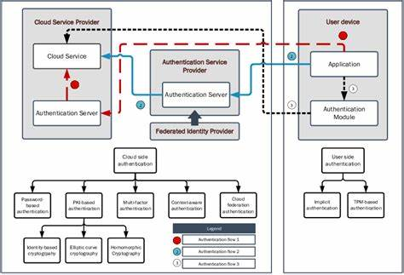

**UML Diagrams:**

**CLASS DIAGRAM:**

The class diagram is used to refine the use case diagram and define a detailed design of the system. The class diagram classifies the actors defined in the use case diagram into a set of interrelated classes. The relationship or association between the classes can be either an "is-a" or "has-a" relationship. Each class in the class diagram may be capable of providing certain functionalities. These functionalities provided by the class are termed "methods" of the class. Apart from this, each class may have certain "attributes" that uniquely.

****

**Use case Diagram:**

A use case diagram in the Unified Modeling Language (UML) is a type of behavioral diagram defined by and created from a Use-case analysis. Its purpose is to present a graphical overview of the functionality provided by a system in terms of actors, their goals (represented as use cases), and any dependencies between those use cases. The main purpose of a use case diagram is to show what system functions are performed for which actor. Roles of the actors in the system can be depicted.

****

**Sequence Diagram:**

A sequence diagram represents the interaction between different objects in the system. The important aspect of a sequence diagram is that it is time-ordered. This means that the exact sequence of the interactions between the objects is represented step by step. Different objects in the sequence diagram interact with each other by passing "messages".

****

**Collaborative Diagram:**

A collaboration diagram groups together the interactions between different objects. The interactions are listed as numbered interactions that help to trace the sequence of the interactions. The collaboration diagram helps to identify all the possible interactions that each object has with other objects.

****

**System Implementations:**

#### 1. System Architecture Design

The implementation begins with designing the overall architecture of the peer-to-peer cloud network. This includes defining the roles of participating peers, the communication protocols used, and the flow of the authentication and key agreement processes. The architecture ensures decentralization by avoiding reliance on any central server, instead enabling direct peer interactions through anonymous identity verification.

#### 2. Cryptographic Module Development

The core of the system lies in its cryptographic operations. Elliptic Curve Cryptography (ECC) algorithms are implemented to facilitate anonymous identity generation, mutual authentication, and secure session key establishment. The module handles key pair generation, signature creation, and verification, as well as secure key exchange protocols, all optimized for performance on limited-resource devices.

#### 3. Anonymous Identity Management

A dedicated component manages anonymous identities, creating pseudonymous credentials for peers during the authentication process. This module ensures that real user identities remain hidden, while still enabling verifiable authentication. It also supports identity revocation and updates to maintain security over time.

#### 4. Secure Communication Protocols

Once authentication and key agreement are successful, secure communication channels are established using the generated session keys. The system implements encryption and decryption mechanisms for data exchange, guaranteeing confidentiality, integrity, and resistance to eavesdropping or tampering.

#### 5. Network Simulation and Testing

The proposed system is deployed and tested in a simulated peer-to-peer cloud environment. Various scenarios are tested, including peer join/leave operations, attack attempts, and performance benchmarks. This phase validates the robustness, scalability, and efficiency of the authentication and key agreement protocols under realistic network conditions.

**System Environment:**

# What is Python :-

Below are some facts about Python.

Python is currently the most widely used multi-purpose, high-level programming language.

Python allows programming in Object-Oriented and Procedural paradigms. Python programs generally are smaller than other programming languages like Java.

Programmers have to type relatively less and indentation requirement of the language, makes them readable all the time.

Python language is being used by almost all tech-giant companies like – Google, Amazon, Facebook, Instagram, Dropbox, Uber… etc.

The biggest strength of Python is huge collection of standard library which can be used for the following .

* + [Machine Learning](https://www.geeksforgeeks.org/machine-learning/)
  + GUI Applications (like Kivy, Tkinter, PyQt etc. )
  + Web frameworks like Django (used by YouTube, Instagram, Dropbox)
  + Image processing (like Opencv, Pillow)
  + Web scraping (like Scrapy, BeautifulSoup, Selenium)
  + Test frameworks
  + Multimedia

### **Advantages of Python :-**

Let’s see how Python dominates over other languages.

#### 1. Extensive Libraries

Python downloads with an extensive library and it contain code for various purposes like regular expressions, documentation-generation, unit-testing, web browsers, threading, databases, CGI, email, image manipulation, and more. So, we don’t have to write the complete code for that manually.

#### 2. Extensible

As we have seen earlier, Python can be**extended to other languages**. You can write some of your code in languages like C++ or C. This comes in handy, especially in projects.

#### 3. Embeddable

Complimentary to extensibility, Python is embeddable as well. You can put your Python code in your source code of a different language, like C++. This lets us add **scripting capabilities**to our code in the other language.

#### 4. Improved Productivity

The language’s simplicity and extensive libraries render programmers**more productive** than languages like Java and C++ do. Also, the fact that you need to write less and get more things done.

#### 5. IOT Opportunities

Since Python forms the basis of new platforms like Raspberry Pi, it finds the future bright for the Internet Of Things. This is a way to connect the language with the real world.

#### 6. Simple and Easy

When working with Java, you may have to create a class to print **‘Hello World’**. But in Python, just a print statement will do. It is also quite **easy to learn, understand,** and**code.** This is why when people pick up Python, they have a hard time adjusting to other more verbose languages like Java.

#### 7. Readable

Because it is not such a verbose language, reading Python is much like reading English. This is the reason why it is so easy to learn, understand, and code. It also does not need curly braces to define blocks, and **indentation is mandatory.** This further aids the readability of the code.

#### 8. Object-Oriented

This language supports both the **procedural and object-oriented**programming paradigms. While functions help us with code reusability, classes and objects let us model the real world. A class allows the **encapsulation of data** and functions into one.

#### 9. Free and Open-Source

Like we said earlier, Python is **freely available.** But not only can you[**download Python**](https://data-flair.training/blogs/install-python-windows/) for free, but you can also download its source code, make changes to it, and even distribute it. It downloads with an extensive collection of libraries to help you with your tasks.

#### 10. Portable

When you code your project in a language like C++, you may need to make some changes to it if you want to run it on another platform. But it isn’t the same with Python. Here, you need to**code only once**, and you can run it anywhere. This is called **Write Once Run Anywhere (WORA)**. However, you need to be careful enough not to include any system-dependent features.

#### 11. Interpreted

Lastly, we will say that it is an interpreted language. Since statements are executed one by one, **debugging is easier** than in compiled languages.

Any doubts till now in the advantages of Python? Mention in the comment section.

### **Advantages of Python Over Other Languages**

#### 1. Less Coding

Almost all of the tasks done in Python requires less coding when the same task is done in other languages. Python also has an awesome standard library support, so you don’t have to search for any third-party libraries to get your job done. This is the reason that many people suggest learning Python to beginners.

#### 2. Affordable

Python is free therefore individuals, small companies or big organizations can leverage the free available resources to build applications. Python is popular and widely used so it gives you better community support.

**The 2019 Github annual survey showed us that Python has overtaken Java in the most popular programming language category.**

#### 3. Python is for Everyone

Python code can run on any machine whether it is Linux, Mac or Windows. Programmers need to learn different languages for different jobs but with Python, you can professionally build web apps, perform data analysis and [**machine learning**](https://data-flair.training/blogs/machine-learning-tutorials-home/), automate things, do web scraping and also build games and powerful visualizations. It is an all-rounder programming language.

### **Disadvantages of Python**

So far, we’ve seen why Python is a great choice for your project. But if you choose it, you should be aware of its consequences as well. Let’s now see the downsides of choosing Python over another language.

#### 1. Speed Limitations

We have seen that Python code is executed line by line. But since [Python](https://www.python.org/) is interpreted, it often results in **slow execution**. This, however, isn’t a problem unless speed is a focal point for the project. In other words, unless high speed is a requirement, the benefits offered by Python are enough to distract us from its speed limitations.

#### 2. Weak in Mobile Computing and Browsers

While it serves as an excellent server-side language, Python is much rarely seen on the **client-side**. Besides that, it is rarely ever used to implement smartphone-based applications. One such application is called **Carbonnelle**.

The reason it is not so famous despite the existence of Brython is that it isn’t that secure.

#### 3. Design Restrictions

As you know, Python is **dynamically-typed**. This means that you don’t need to declare the type of variable while writing the code. It uses **duck-typing**. But wait, what’s that? Well, it just means that if it looks like a duck, it must be a duck. While this is easy on the programmers during coding, it can**raise run-time errors**.

#### 4. Underdeveloped Database Access Layers

Compared to more widely used technologies like **JDBC (Java DataBase Connectivity)** and **ODBC (Open DataBase Connectivity)**, Python’s database access layers are a bit underdeveloped. Consequently, it is less often applied in huge enterprises.

#### 5. Simple

No, we’re not kidding. Python’s simplicity can indeed be a problem. Take my example. I don’t do Java, I’m more of a Python person. To me, its syntax is so simple that the verbosity of Java code seems unnecessary.

This was all about the Advantages and Disadvantages of Python Programming Language.

**History of Python : -**

What do the alphabet and the programming language Python have in common? Right, both start with ABC. If we are talking about ABC in the Python context, it's clear that the programming language ABC is meant. ABC is a general-purpose programming language and programming environment, which had been developed in the Netherlands, Amsterdam, at the CWI (Centrum Wiskunde &Informatica). The greatest achievement of ABC was to influence the design of Python.Python was conceptualized in the late 1980s. Guido van Rossum worked that time in a project at the CWI, called Amoeba, a distributed operating system. In an interview with Bill Venners1, Guido van Rossum said: "In the early 1980s, I worked as an implementer on a team building a language called ABC at Centrum voor Wiskunde en Informatica (CWI).

I don't know how well people know ABC's influence on Python. I try to mention ABC's influence because I'm indebted to everything I learned during that project and to the people who worked on it."Later on in the same Interview, Guido van Rossum continued: "I remembered all my experience and some of my frustration with ABC. I decided to try to design a simple scripting language that possessed some of ABC's better properties, but without its problems. So I started typing. I created a simple virtual machine, a simple parser, and a simple runtime. I made my own version of the various ABC parts that I liked. I created a basic syntax, used indentation for statement grouping instead of curly braces or begin-end blocks, and developed a small number of powerful data types: a hash table (or dictionary, as we call it), a list, strings, and numbers."

**What is Machine Learning : -**

Before we take a look at the details of various machine learning methods, let's start by looking at what machine learning is, and what it isn't. Machine learning is often categorized as a subfield of artificial intelligence, but I find that categorization can often be misleading at first brush. The study of machine learning certainly arose from research in this context, but in the data science application of machine learning methods, it's more helpful to think of machine learning as a means of building models of data.

Fundamentally, machine learning involves building mathematical models to help understand data. "Learning" enters the fray when we give these models tunable parameters that can be adapted to observed data; in this way the program can be considered to be "learning" from the data.

Once these models have been fit to previously seen data, they can be used to predict and understand aspects of newly observed data. I'll leave to the reader the more philosophical digression regarding the extent to which this type of mathematical, model-based "learning" is similar to the "learning" exhibited by the human brain.Understanding the problem setting in machine learning is essential to using these tools effectively, and so we will start with some broad categorizations of the types of approaches we'll discuss here.

**Categories Of Machine Leaning :-**

At the most fundamental level, machine learning can be categorized into two main types: supervised learning and unsupervised learning.

Supervised learning involves somehow modeling the relationship between measured features of data and some label associated with the data; once this model is determined, it can be used to apply labels to new, unknown data. This is further subdivided into classification tasks and regression tasks: in classification, the labels are discrete categories, while in regression, the labels are continuous quantities. We will see examples of both types of supervised learning in the following section.

Unsupervised learning involves modeling the features of a dataset without reference to any label, and is often described as "letting the dataset speak for itself." These models include tasks such as clustering and dimensionality reduction.

Clustering algorithms identify distinct groups of data, while dimensionality reduction algorithms search for more succinct representations of the data. We will see examples of both types of unsupervised learning in the following section.

## Need for Machine Learning

Human beings, at this moment, are the most intelligent and advanced species on earth because they can think, evaluate and solve complex problems. On the other side, AI is still in its initial stage and haven’t surpassed human intelligence in many aspects. Then the question is that what is the need to make machine learn? The most suitable reason for doing this is, “to make decisions, based on data, with efficiency and scale”.

Lately, organizations are investing heavily in newer technologies like Artificial Intelligence, Machine Learning and Deep Learning to get the key information from data to perform several real-world tasks and solve problems. We can call it data-driven decisions taken by machines, particularly to automate the process. These data-driven decisions can be used, instead of using programing logic, in the problems that cannot be programmed inherently. The fact is that we can’t do without human intelligence, but other aspect is that we all need to solve real-world problems with efficiency at a huge scale. That is why the need for machine learning arises.

## Challenges in Machines Learning :-

While Machine Learning is rapidly evolving, making significant strides with cybersecurity and autonomous cars, this segment of AI as whole still has a long way to go. The reason behind is that ML has not been able to overcome number of challenges. The challenges that ML is facing currently are −

**Quality of data** − Having good-quality data for ML algorithms is one of the biggest challenges. Use of low-quality data leads to the problems related to data preprocessing and feature extraction.

**Time-Consuming task** − Another challenge faced by ML models is the consumption of time especially for data acquisition, feature extraction and retrieval.

**Lack of specialist persons** − As ML technology is still in its infancy stage, availability of expert resources is a tough job.

**No clear objective for formulating business problems** − Having no clear objective and well-defined goal for business problems is another key challenge for ML because this technology is not that mature yet.

**Issue of overfitting & underfitting** − If the model is overfitting or underfitting, it cannot be represented well for the problem.

**Curse of dimensionality** − Another challenge ML model faces is too many features of data points. This can be a real hindrance.

**Difficulty in deployment** − Complexity of the ML model makes it quite difficult to be deployed in real life.

## Applications of Machines Learning :-

Machine Learning is the most rapidly growing technology and according to researchers we are in the golden year of AI and ML. It is used to solve many real-world complex problems which cannot be solved with traditional approach. Following are some real-world applications of ML −

* Emotion analysis
* Sentiment analysis
* Error detection and prevention
* Weather forecasting and prediction
* Stock market analysis and forecasting
* Speech synthesis
* Speech recognition
* Customer segmentation
* Object recognition
* Fraud detection
* Fraud prevention
* Recommendation of products to customer in online shopping

# How to Start Learning Machine Learning?

Arthur Samuel coined the term **“Machine Learning”** in 1959 and defined it as a **“Field of study that gives computers the capability to learn without being explicitly programmed”.**

And that was the beginning of Machine Learning! In modern times, Machine Learning is one of the most popular (if not the most!) career choices. According to [Indeed](http://blog.indeed.com/2019/03/14/best-jobs-2019/), Machine Learning Engineer Is The Best Job of 2019 with a 344% growth and an average base salary of **$146,085** per year.

But there is still a lot of doubt about what exactly is Machine Learning and how to start learning it? So this article deals with the Basics of Machine Learning and also the path you can follow to eventually become a full-fledged Machine Learning Engineer. Now let’s get started!!!

### **How to start learning ML?**

This is a rough roadmap you can follow on your way to becoming an insanely talented Machine Learning Engineer. Of course, you can always modify the steps according to your needs to reach your desired end-goal!

### Step 1 – Understand the Prerequisites

In case you are a genius, you could start ML directly but normally, there are some prerequisites that you need to know which include Linear Algebra, Multivariate Calculus, Statistics, and Python. And if you don’t know these, never fear! You don’t need a Ph.D. degree in these topics to get started but you do need a basic understanding.

#### (a) Learn Linear Algebra and Multivariate Calculus

Both Linear Algebra and Multivariate Calculus are important in Machine Learning. However, the extent to which you need them depends on your role as a data scientist. If you are more focused on application heavy machine learning, then you will not be that heavily focused on maths as there are many common libraries available. But if you want to focus on R&D in Machine Learning, then mastery of Linear Algebra and Multivariate Calculus is very important as you will have to implement many ML algorithms from scratch.

#### (b) Learn Statistics

Data plays a huge role in Machine Learning. In fact, around 80% of your time as an ML expert will be spent collecting and cleaning data. And statistics is a field that handles the collection, analysis, and presentation of data. So it is no surprise that you need to learn it!!!  
Some of the key concepts in statistics that are important are Statistical Significance, Probability Distributions, Hypothesis Testing, Regression, etc. Also, Bayesian Thinking is also a very important part of ML which deals with various concepts like Conditional Probability, Priors, and Posteriors, Maximum Likelihood, etc.

#### (c) Learn Python

Some people prefer to skip Linear Algebra, Multivariate Calculus and Statistics and learn them as they go along with trial and error. But the one thing that you absolutely cannot skip is [Python](https://www.geeksforgeeks.org/python-programming-language/)! While there are other languages you can use for Machine Learning like R, Scala, etc. Python is currently the most popular language for ML. In fact, there are many Python libraries that are specifically useful for Artificial Intelligence and Machine Learning such as [Keras](https://keras.io/" \t "_blank), [TensorFlow](https://www.tensorflow.org/" \t "_blank), [Scikit-learn](https://scikit-learn.org/stable/" \t "_blank), etc.

So if you want to learn ML, it’s best if you learn Python! You can do that using various online resources and courses such as [**Fork Python**](https://practice.geeksforgeeks.org/courses/fork-python) available Free on GeeksforGeeks.

### **Step 2 – Learn Various ML Concepts**

Now that you are done with the prerequisites, you can move on to actually learning ML (Which is the fun part!!!) It’s best to start with the basics and then move on to the more complicated stuff. Some of the basic concepts in ML are:

#### (a) Terminologies of Machine Learning

* **Model –**A model is a specific representation learned from data by applying some machine learning algorithm. A model is also called a hypothesis.
* **Feature –**A feature is an individual measurable property of the data. A set of numeric features can be conveniently described by a feature vector. Feature vectors are fed as input to the model. For example, in order to predict a fruit, there may be features like color, smell, taste, etc.
* **Target (Label) –**A target variable or label is the value to be predicted by our model. For the fruit example discussed in the feature section, the label with each set of input would be the name of the fruit like apple, orange, banana, etc.
* **Training –**The idea is to give a set of inputs(features) and it’s expected outputs(labels), so after training, we will have a model (hypothesis) that will then map new data to one of the categories trained on.
* **Prediction –**Once our model is ready, it can be fed a set of inputs to which it will provide a predicted output(label).

#### (b) Types of Machine Learning

* **Supervised Learning –**This involves learning from a training dataset with labeled data using classification and regression models. This learning process continues until the required level of performance is achieved.
* **Unsupervised Learning –**This involves using unlabelled data and then finding the underlying structure in the data in order to learn more and more about the data itself using factor and cluster analysis models.
* **Semi-supervised Learning –**This involves using unlabelled data like Unsupervised Learning with a small amount of labeled data. Using labeled data vastly increases the learning accuracy and is also more cost-effective than Supervised Learning.
* **Reinforcement Learning –**This involves learning optimal actions through trial and error. So the next action is decided by learning behaviors that are based on the current state and that will maximize the reward in the future.

### **Advantages of Machine learning :-**

#### 1. Easily identifies trends and patterns -

Machine Learning can review large volumes of data and discover specific trends and patterns that would not be apparent to humans. For instance, for an e-commerce website like Amazon, it serves to understand the browsing behaviors and purchase histories of its users to help cater to the right products, deals, and reminders relevant to them. It uses the results to reveal relevant advertisements to them.

#### 2. No human intervention needed (automation)

With ML, you don’t need to babysit your project every step of the way. Since it means giving machines the ability to learn, it lets them make predictions and also improve the algorithms on their own. A common example of this is anti-virus softwares; they learn to filter new threats as they are recognized. ML is also good at recognizing spam.

#### 3. Continuous Improvement

As [**ML algorithms**](https://data-flair.training/blogs/machine-learning-algorithms/) gain experience, they keep improving in accuracy and efficiency. This lets them make better decisions. Say you need to make a weather forecast model. As the amount of data you have keeps growing, your algorithms learn to make more accurate predictions faster.

#### 4. Handling multi-dimensional and multi-variety data

Machine Learning algorithms are good at handling data that are multi-dimensional and multi-variety, and they can do this in dynamic or uncertain environments.

#### 5. Wide Applications

You could be an e-tailer or a healthcare provider and make ML work for you. Where it does apply, it holds the capability to help deliver a much more personal experience to customers while also targeting the right customers.

### **Disadvantages of Machine Learning :-**

#### 1. Data Acquisition

Machine Learning requires massive data sets to train on, and these should be inclusive/unbiased, and of good quality. There can also be times where they must wait for new data to be generated.

#### 2. Time and Resources

ML needs enough time to let the algorithms learn and develop enough to fulfill their purpose with a considerable amount of accuracy and relevancy. It also needs massive resources to function. This can mean additional requirements of computer power for you.

#### 3. Interpretation of Results

Another major challenge is the ability to accurately interpret results generated by the algorithms. You must also carefully choose the algorithms for your purpose.

#### 4. High error-susceptibility

[Machine Learning](https://en.wikipedia.org/wiki/Machine_learning) is autonomous but highly susceptible to errors. Suppose you train an algorithm with data sets small enough to not be inclusive. You end up with biased predictions coming from a biased training set. This leads to irrelevant advertisements being displayed to customers. In the case of ML, such blunders can set off a chain of errors that can go undetected for long periods of time. And when they do get noticed, it takes quite some time to recognize the source of the issue, and even longer to correct it.

**Python Development Steps : -**

Guido Van Rossum published the first version of Python code (version 0.9.0) at alt.sources in February 1991. This release included already exception handling, functions, and the core data types of list, dict, str and others. It was also object oriented and had a module system.  
Python version 1.0 was released in January 1994. The major new features included in this release were the functional programming tools lambda, map, filter and reduce, which Guido Van Rossum never liked.Six and a half years later in October 2000, Python 2.0 was introduced. This release included list comprehensions, a full garbage collector and it was supporting unicode.Python flourished for another 8 years in the versions 2.x before the next major release as Python 3.0 (also known as "Python 3000" and "Py3K") was released. Python 3 is not backwards compatible with Python 2.x.

The emphasis in Python 3 had been on the removal of duplicate programming constructs and modules, thus fulfilling or coming close to fulfilling the 13th law of the Zen of Python: "There should be one -- and preferably only one -- obvious way to do it."Some changes in Python 7.3:

* Print is now a function
* Views and iterators instead of lists
* The rules for ordering comparisons have been simplified. E.g. a heterogeneous list cannot be sorted, because all the elements of a list must be comparable to each other.
* There is only one integer type left, i.e. int. long is int as well.
* The division of two integers returns a float instead of an integer. "//" can be used to have the "old" behaviour.
* Text Vs. Data Instead Of Unicode Vs. 8-bit

**Purpose :-**

We demonstrated that our approach enables successful segmentation of intra-retinal layers—even with low-quality images containing speckle noise, low contrast, and different intensity ranges throughout—with the assistance of the ANIS feature.

**Python**

Python is an interpreted high-level programming language for general-purpose programming. Created by Guido van Rossum and first released in 1991, Python has a design philosophy that emphasizes code readability, notably using significant whitespace.

Python features a dynamic type system and automatic memory management. It supports multiple programming paradigms, including object-oriented, imperative, functional and procedural, and has a large and comprehensive standard library.

* Python is Interpreted − Python is processed at runtime by the interpreter. You do not need to compile your program before executing it. This is similar to PERL and PHP.
* Python is Interactive − you can actually sit at a Python prompt and interact with the interpreter directly to write your programs.

Python also acknowledges that speed of development is important. Readable and terse code is part of this, and so is access to powerful constructs that avoid tedious repetition of code. Maintainability also ties into this may be an all but useless metric, but it does say something about how much code you have to scan, read and/or understand to troubleshoot problems or tweak behaviors. This speed of development, the ease with which a programmer of other languages can pick up basic Python skills and the huge standard library is key to another area where Python excels. All its tools have been quick to implement, saved a lot of time, and several of them have later been patched and updated by people with no Python background - without breaking.

**Modules Used in Project :-**

**Tensorflow**

TensorFlow is a [free](https://en.wikipedia.org/wiki/Free_software) and [open-source](https://en.wikipedia.org/wiki/Open-source_software) [software library for dataflow and differentiable programming](https://en.wikipedia.org/wiki/Library_(computing)) across a range of tasks. It is a symbolic math library, and is also used for [machine learning](https://en.wikipedia.org/wiki/Machine_learning) applications such as [neural networks](https://en.wikipedia.org/wiki/Neural_networks). It is used for both research and production at [Google](https://en.wikipedia.org/wiki/Google).‍

TensorFlow was developed by the [Google Brain](https://en.wikipedia.org/wiki/Google_Brain) team for internal Google use. It was released under the [Apache 2.0](https://en.wikipedia.org/wiki/Apache_License) [open-source license](https://en.wikipedia.org/wiki/Open-source_license) on November 9, 2015.

**Numpy**

Numpy is a general-purpose array-processing package. It provides a high-performance multidimensional array object, and tools for working with these arrays.

It is the fundamental package for scientific computing with Python. It contains various features including these important ones:

* A powerful N-dimensional array object
* Sophisticated (broadcasting) functions
* Tools for integrating C/C++ and Fortran code
* Useful linear algebra, Fourier transform, and random number capabilities

Besides its obvious scientific uses, Numpy can also be used as an efficient multi-dimensional container of generic data. Arbitrary data-types can be defined using Numpy which allows Numpy to seamlessly and speedily integrate with a wide variety of databases.

**Pandas**

Pandas is an open-source Python Library providing high-performance data manipulation and analysis tool using its powerful data structures. Python was majorly used for data munging and preparation. It had very little contribution towards data analysis. Pandas solved this problem. Using Pandas, we can accomplish five typical steps in the processing and analysis of data, regardless of the origin of data load, prepare, manipulate, model, and analyze. Python with Pandas is used in a wide range of fields including academic and commercial domains including finance, economics, Statistics, analytics, etc.

**Matplotlib**

Matplotlib is a Python 2D plotting library which produces publication quality figures in a variety of hardcopy formats and interactive environments across platforms. Matplotlib can be used in Python scripts, the Python and [IPython](http://ipython.org/) shells, the [Jupyter](http://jupyter.org/) Notebook, web application servers, and four graphical user interface toolkits. Matplotlib tries to make easy things easy and hard things possible. You can generate plots, histograms, power spectra, bar charts, error charts, scatter plots, etc., with just a few lines of code. For examples, see the [sample plots](https://matplotlib.org/tutorials/introductory/sample_plots.html) and [thumbnail gallery](https://matplotlib.org/gallery/index.html).

For simple plotting the pyplot module provides a MATLAB-like interface, particularly when combined with IPython. For the power user, you have full control of line styles, font properties, axes properties, etc, via an object oriented interface or via a set of functions familiar to MATLAB users.

**Scikit – learn**

Scikit-learn provides a range of supervised and unsupervised learning algorithms via a consistent interface in Python. It is licensed under a permissive simplified BSD license and is distributed under many Linux distributions, encouraging academic and commercial use. **Python**

Python is an interpreted high-level programming language for general-purpose programming. Created by Guido van Rossum and first released in 1991, Python has a design philosophy that emphasizes code readability, notably using significant whitespace.

Python features a dynamic type system and automatic memory management. It supports multiple programming paradigms, including object-oriented, imperative, functional and procedural, and has a large and comprehensive standard library.

* Python is Interpreted − Python is processed at runtime by the interpreter. You do not need to compile your program before executing it. This is similar to PERL and PHP.
* Python is Interactive − you can actually sit at a Python prompt and interact with the interpreter directly to write your programs.

Python also acknowledges that speed of development is important. Readable and terse code is part of this, and so is access to powerful constructs that avoid tedious repetition of code. Maintainability also ties into this may be an all but useless metric, but it does say something about how much code you have to scan, read and/or understand to troubleshoot problems or tweak behaviors. This speed of development, the ease with which a programmer of other languages can pick up basic Python skills and the huge standard library is key to another area where Python excels.

All its tools have been quick to implement, saved a lot of time, and several of them have later been patched and updated by people with no Python background - without breaking.

**Install Python Step-by-Step in Windows and Mac :**

Python a versatile programming language doesn’t come pre-installed on your computer devices. Python was first released in the year 1991 and until today it is a very popular high-level programming language. Its style philosophy emphasizes code readability with its notable use of great whitespace.

The object-oriented approach and language construct provided by Python enables programmers to write both clear and logical code for projects. This software does not come pre-packaged with Windows.

## How to Install Python on Windows and Mac :

There have been several updates in the Python version over the years. The question is how to install Python? It might be confusing for the beginner who is willing to start learning Python but this tutorial will solve your query. The latest or the newest version of Python is version 3.7.4 or in other words, it is Python 3.

**Note:** The python version 3.7.4 cannot be used on Windows XP or earlier devices.

Before you start with the installation process of Python. First, you need to know about your **System Requirements**. Based on your system type i.e. operating system and based processor, you must download the python version. My system type is a **Windows 64-bit operating system**. So the steps below are to install python version 3.7.4 on Windows 7 device or to install Python 3. [Download the Python Cheatsheet here.](https://myelearninghub.com/python-cheat-sheet/)The steps on how to install Python on Windows 10, 8 and 7 are **divided into 4 parts** to help understand better.

### Download the Correct version into the system

**Step 1:** Go to the official site to download and install python using Google Chrome or any other web browser. OR Click on the following link: [https://www.python.org](https://www.python.org/)

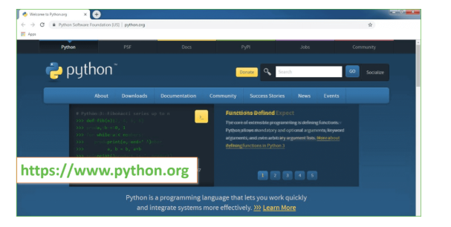

Now, check for the latest and the correct version for your operating system.

**Step 2:** Click on the Download Tab.

**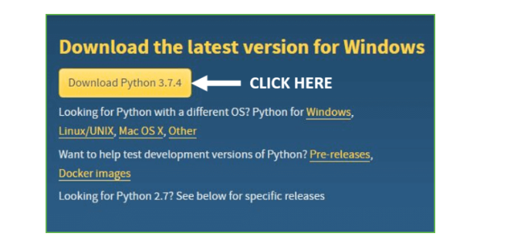**

**Step 3:** You can either select the Download Python for windows 3.7.4 button in Yellow Color or you can scroll further down and click on download with respective to their version. Here, we are downloading the most recent python version for windows 3.7.4

**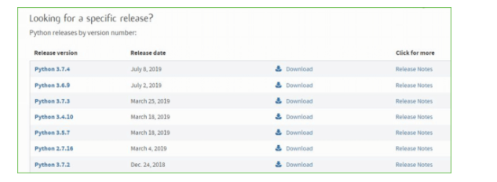**

**Step 4:** Scroll down the page until you find the Files option.

**Step 5:** Here you see a different version of python along with the operating system.

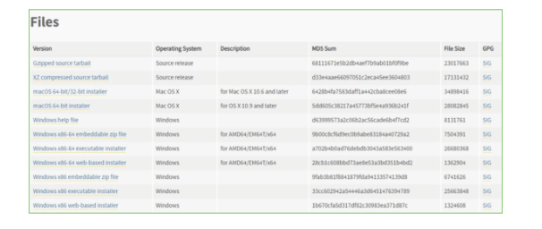

• To download Windows 32-bit python, you can select any one from the three options: Windows x86 embeddable zip file, Windows x86 executable installer or Windows x86 web-based installer.

•To download Windows 64-bit python, you can select any one from the three options: Windows x86-64 embeddable zip file, Windows x86-64 executable installer or Windows x86-64 web-based installer.

Here we will install Windows x86-64 web-based installer. Here your first part regarding which version of python is to be downloaded is completed. Now we move ahead with the second part in installing python i.e. Installation

**Note:** To know the changes or updates that are made in the version you can click on the Release Note Option.

### Installation of Python

**Step 1:** Go to Download and Open the downloaded python version to carry out the installation process.

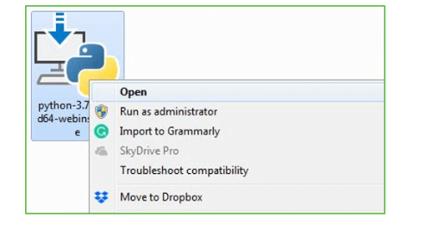

**Step 2:** Before you click on Install Now, Make sure to put a tick on Add Python 3.7 to PATH.

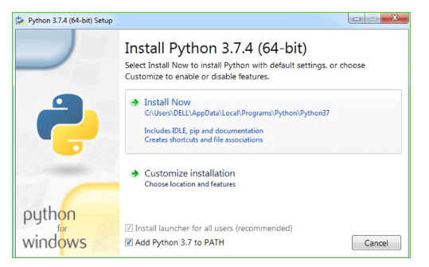

**Step 3:** Click on Install NOW After the installation is successful. Click on Close.

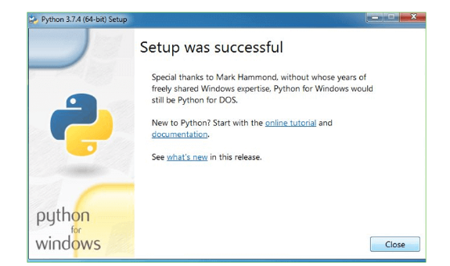

With these above three steps on python installation, you have successfully and correctly installed Python. Now is the time to verify the installation.

**Note:** The installation process might take a couple of minutes.

### Verify the Python Installation

**Step 1:** Click on Start

**Step 2:** In the Windows Run Command, type “cmd”.

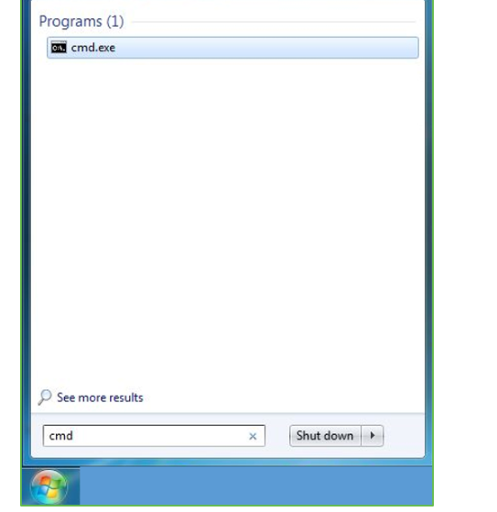

**Step 3:** Open the Command prompt option.

**Step 4:** Let us test whether the python is correctly installed. Type **python –V** and press Enter.

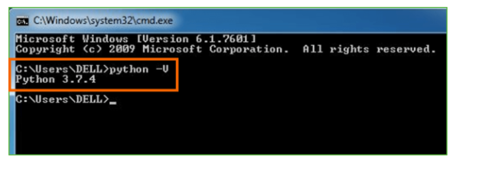

**Step 5:** You will get the answer as 3.7.4

**Note:** If you have any of the earlier versions of Python already installed. You must first uninstall the earlier version and then install the new one.

### Check how the Python IDLE works

**Step 1:** Click on Start

**Step 2:** In the Windows Run command, type “python idle”.

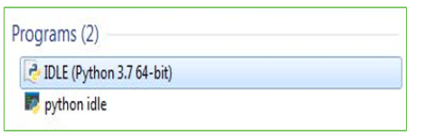

**Step 3:** Click on IDLE (Python 3.7 64-bit) and launch the program

**Step 4:** To go ahead with working in IDLE you must first save the file. **Click on File > Click on Save**

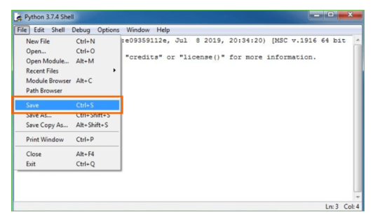

**Step 5:** Name the file and save as type should be Python files. Click on SAVE. Here I have named the files as Hey World.

**Step 6:** Now for e.g. **enter print**

**SYSTEM TEST**

The purpose of testing is to discover errors. Testing is the process of trying to discover every conceivable fault or weakness in a work product. It provides a way to check the functionality of components, sub assemblies, assemblies and/or a finished product It is the process of exercising software with the intent of ensuring that the Software system meets its requirements and user expectations and does not fail in an unacceptable manner. There are various types of test. Each test type addresses a specific testing requirement.

### **TYPES OF TESTS**

**Unit testing**

Unit testing involves the design of test cases that validate that the internal program logic is functioning properly, and that program inputs produce valid outputs. All decision branches and internal code flow should be validated. It is the testing of individual software units of the application .it is done after the completion of an individual unit before integration. This is a structural testing, that relies on knowledge of its construction and is invasive. Unit tests perform basic tests at component level and test a specific business process, application, and/or system configuration. Unit tests ensure that each unique path of a business process performs accurately to the documented specifications and contains clearly defined inputs and expected results.

**Integration testing**

Integration tests are designed to test integrated software components to determine if they actually run as one program. Testing is event driven and is more concerned with the basic outcome of screens or fields. Integration tests demonstrate that although the components were individually satisfaction, as shown by successfully unit testing, the combination of components is correct and consistent. Integration testing is specifically aimed at exposing the problems that arise from the combination of components.

**Functional test**

Functional tests provide systematic demonstrations that functions tested are available as specified by the business and technical requirements, system documentation, and user manuals.

Functional testing is centered on the following items:

Valid Input : identified classes of valid input must be accepted.

Invalid Input : identified classes of invalid input must be rejected.

Functions : identified functions must be exercised.

Output : identified classes of application outputs must be exercised.

Systems/Procedures : interfacing systems or procedures must be invoked.

Organization and preparation of functional tests is focused on requirements, key functions, or special test cases. In addition, systematic coverage pertaining to identify Business process flows; data fields, predefined processes, and successive processes must be considered for testing. Before functional testing is complete, additional tests are identified and the effective value of current tests is determined.

**System Test**

System testing ensures that the entire integrated software system meets requirements. It tests a configuration to ensure known and predictable results. An example of system testing is the configuration oriented system integration test. System testing is based on process descriptions and flows, emphasizing pre-driven process links and integration points.

**White Box Testing**

White Box Testing is a testing in which in which the software tester has knowledge of the inner workings, structure and language of the software, or at least its purpose. It is purpose. It is used to test areas that cannot be reached from a black box level.

**Black Box Testing**

Black Box Testing is testing the software without any knowledge of the inner workings, structure or language of the module being tested. Black box tests, as most other kinds of tests, must be written from a definitive source document, such as specification or requirements document, such as specification or requirements document. It is a testing in which the software under test is treated, as a black box .you cannot “see” into it. The test provides inputs and responds to outputs without considering how the software works.

**Unit Testing**

Unit testing is usually conducted as part of a combined code and unit test phase of the software lifecycle, although it is not uncommon for coding and unit testing to be conducted as two distinct phases.

**Test strategy and approach**

Field testing will be performed manually and functional tests will be written in detail.

**Test objectives**

* All field entries must work properly.
* Pages must be activated from the identified link.
* The entry screen, messages and responses must not be delayed.

**Features to be tested**

* Verify that the entries are of the correct format
* No duplicate entries should be allowed
* All links should take the user to the correct page.

# Integration Testing

Software integration testing is the incremental integration testing of two or more integrated software components on a single platform to produce failures caused by interface defects.

The task of the integration test is to check that components or software applications, e.g. components in a software system or – one step up – software applications at the company level – interact without error.

**Test Results:** All the test cases mentioned above passed successfully. No defects encountered.

**Acceptance Testing**

User Acceptance Testing is a critical phase of any project and requires significant participation by the end user. It also ensures that the system meets the functional requirements.

**Test Results:** All the test cases mentioned above passed successfully. No defects encountered.

**Test cases1:**

**Test case for Login form:**

|  |  |
| --- | --- |
| **FUNCTION:** | **LOGIN** |
| **EXPECTED RESULTS:** | Should Validate the user and check his existence in database |
| **ACTUAL RESULTS:** | Validate the user and checking the user against the database |
| **LOW PRIORITY** | **No** |
| **HIGH PRIORITY** | **Yes** |

**Test case2:**

**Test case for User Registration form:**

|  |  |
| --- | --- |
| **FUNCTION:** | **USER REGISTRATION** |
| **EXPECTED RESULTS:** | Should check if all the fields are filled by the user and saving the user to database. |
| **ACTUAL RESULTS:** | Checking whether all the fields are field by user or not through validations and saving user. |
| **LOW PRIORITY** | **No** |
| **HIGH PRIORITY** | **Yes** |

**Test case3:**

**Test case for Change Password:**

When the old password does not match with the new password ,then this results in displaying an error message as “ OLD PASSWORD DOES NOT MATCH WITH THE NEW PASSWORD”.

|  |  |
| --- | --- |
| **FUNCTION:** | **Change Password** |
| **EXPECTED RESULTS:** | Should check if old password and new password fields are filled by the user and saving the user to database. |
| **ACTUAL RESULTS:** | Checking whether all the fields are field by user or not through validations and saving user. |
| **LOW PRIORITY** | **No** |
| **HIGH PRIORITY** | **Yes** |

**SCREEN SHOTS**

Authentication & Key Agreement Based on Anonymous Identity for Peer-to-Peer Cloud

Now-a-days cloud services are using everywhere as it’s provide heavy storage and computation cost at cheaper cost. Data backup at cloud servers cannot be download when user change his mobile or laptop as cloud does not support migration to different providers. To overcome from this issue author of this paper employing Peer-to-Peer services which can be run by all cloud service providers. Peer of 1 cloud can communicate with peer of other cloud to access user data to support migration. During accessing of one cloud peer from other cloud peer can put cloud security at risk as it may leak cloud identity.

To overcome from above issue author employing Anonymous Identity Based Key Agreement and authentication protocol where different peers can communicate with anonymous key identities without leaking actual identity.

In propose work ECC algorithm is used to generate public and private keys and then Diffie Hellman algorithm is used to compute common secret shared between two different peers or parties by using their private and public keys. If both parties utilising same algorithm then same secret will be generated and authentication will get successful. Upon successful authentication both peers can share data between one and other.

In below screen showing python code generating keys and then computing common secret key and then performing authentication.

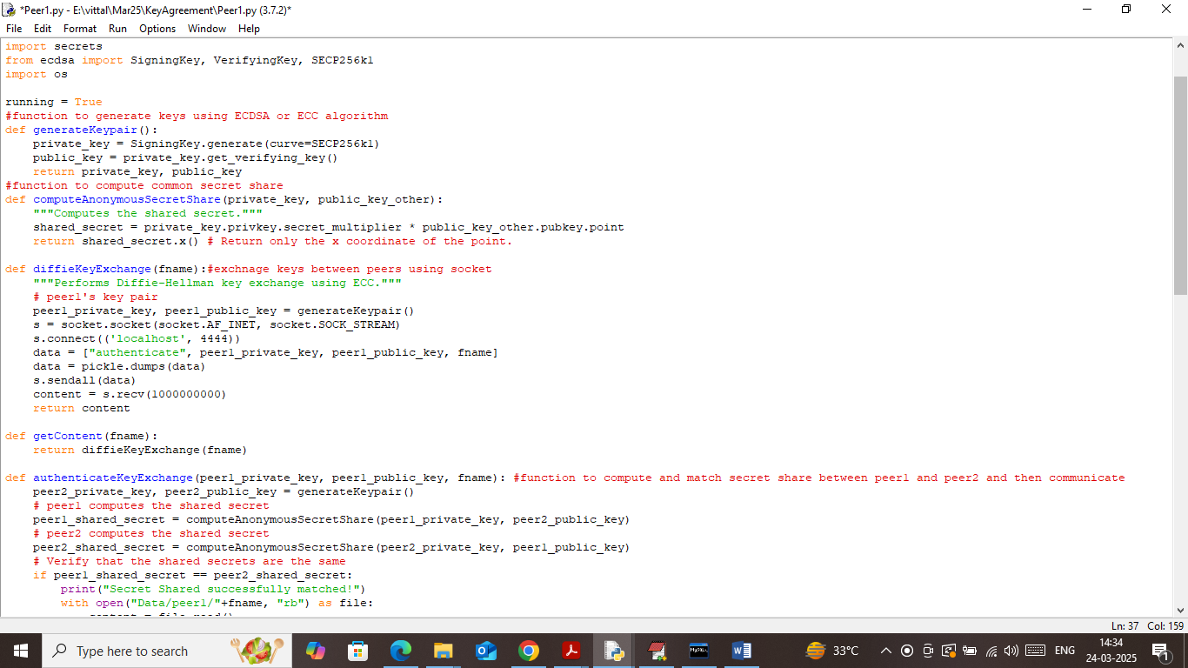

In above screen read red colour comments to know how two peers generate keys, exchange and compare secret share for authentication.

To implement this project we have designed following modules

1. Peer1: Peer1 will be running using socket and can accept request from peer2 for authentication and then share each other files upon successful authentication
2. Peer2: Peer2 will be running using socket and can accept request from peer1 for authentication and then share each other files
3. New User Registration: this service will be run on cloud server where user can sign up with the application
4. User Login: user can login to system
5. Upload File 2 Cloud Peer: after login user can upload file to desired peer with the help of cloud
6. Access File Peer Key Authentication: user can download file from the peer and of file not available at source peer then it will authenticate with other peers using key exchange protocol, upon successful authentication both will exchange file and then send to cloud user for download
7. Computation Cost: using this module will plot communication cost graph between peers as all peers running on THREADS and search in their own memory so its search time will be less compare to single thread server which is searching entire memory for desired file.

SCREEN SHOTS

Install python 3.7.2 and then install all packages given in requirements.txt file. Install MYSQL database and then open MYSQL console and then copy content from ‘database.txt’ file and paste in MYSQL console to create database

First double click on ‘runPeer1.bat’ file to start Peer1 and then will get below page

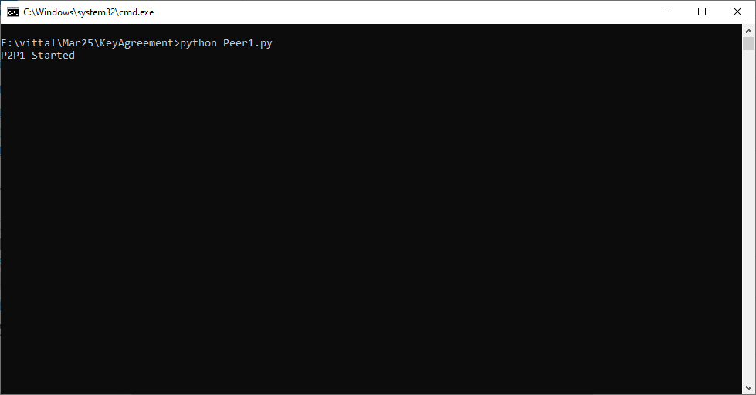

In above screen peer1 started and now double click on ‘runPeer2.bat’ file to start second peer and then will get below page

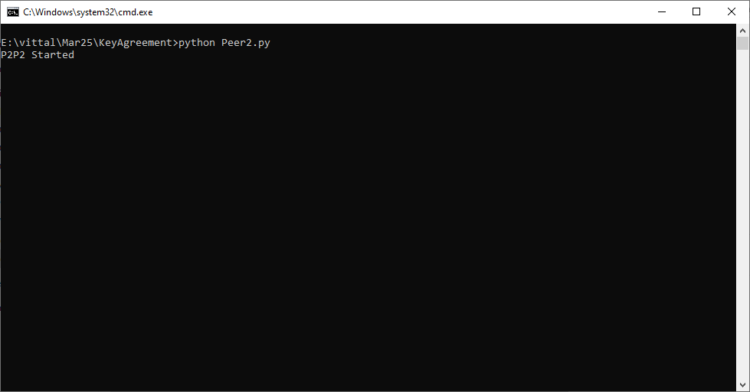

In above screen second peer also started and now double click on ‘runCloud.bat’ file to start cloud server and then will get below page

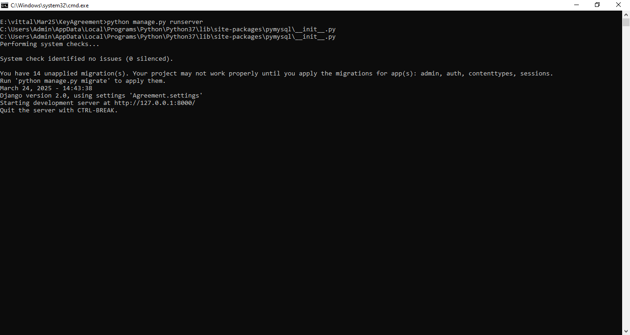

In above screen python cloud server started and now open browser and enter URL as <http://127.0.0.1:8000/index.html> and then press enter key to get below page

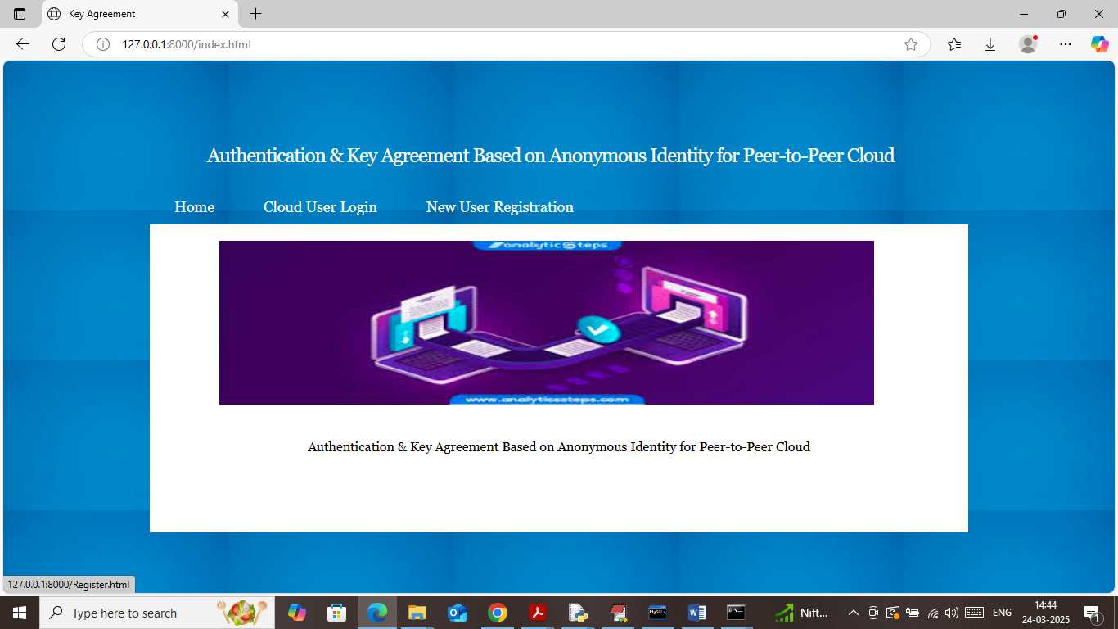

In above screen click on ‘New User Registration’ link to get below page

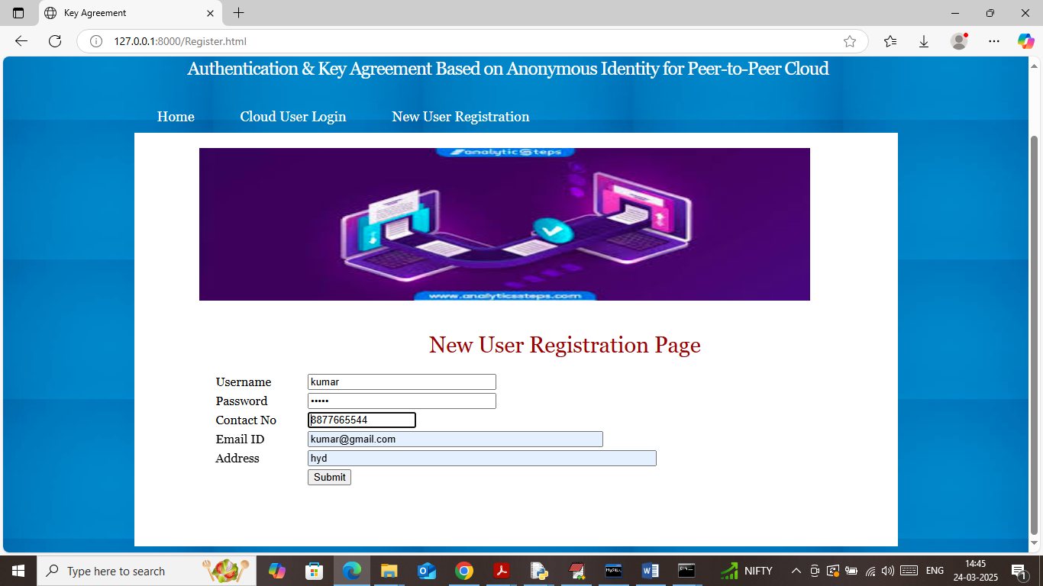

In above screen user is entering sign up details and then press button to get below page

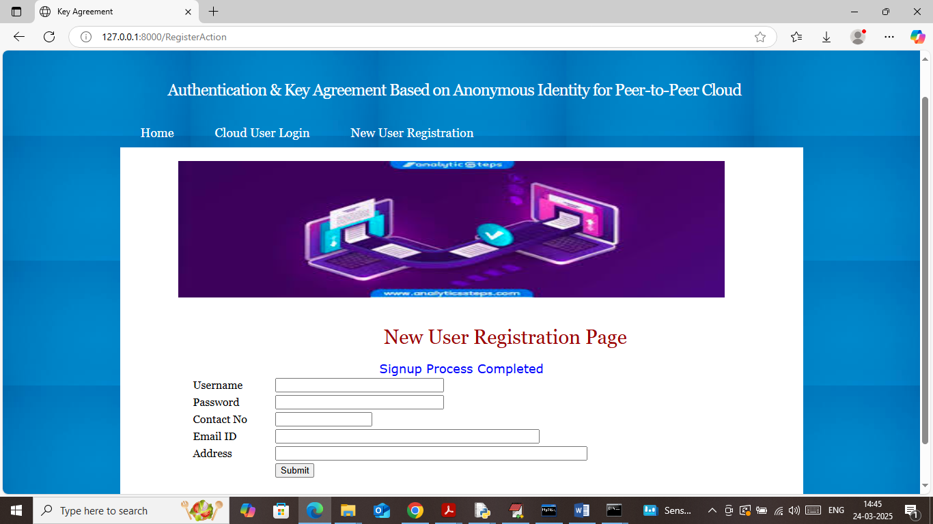

In above screen user sign up completed and now click on ‘User Login’ link to get below page

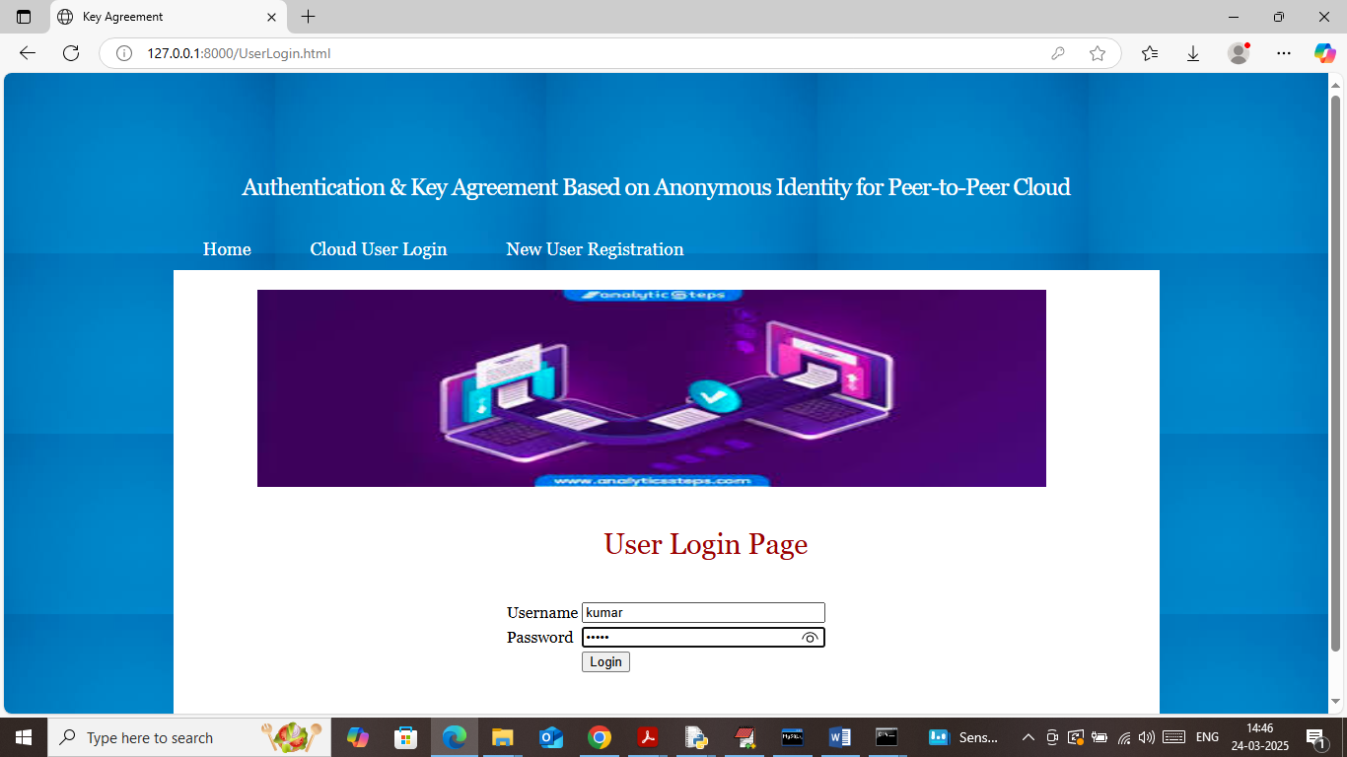

In above screen user is login and after login will get below page

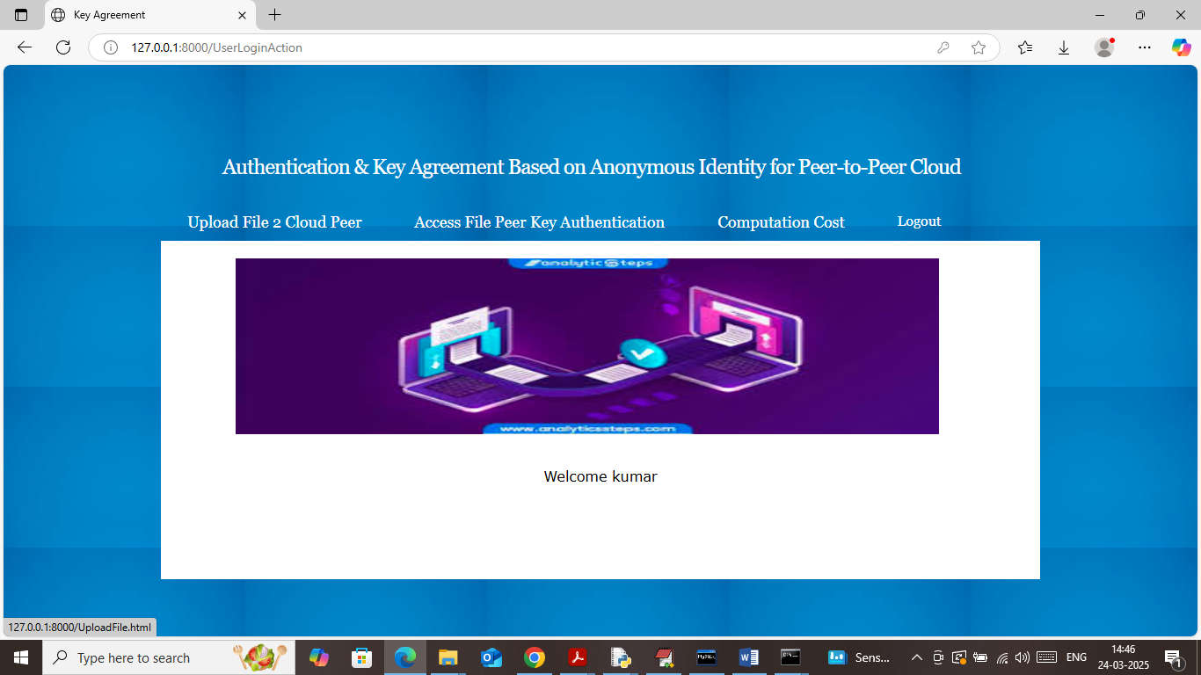

In above screen user can click on ‘Upload File 2 Cloud Peer’ link to get below page

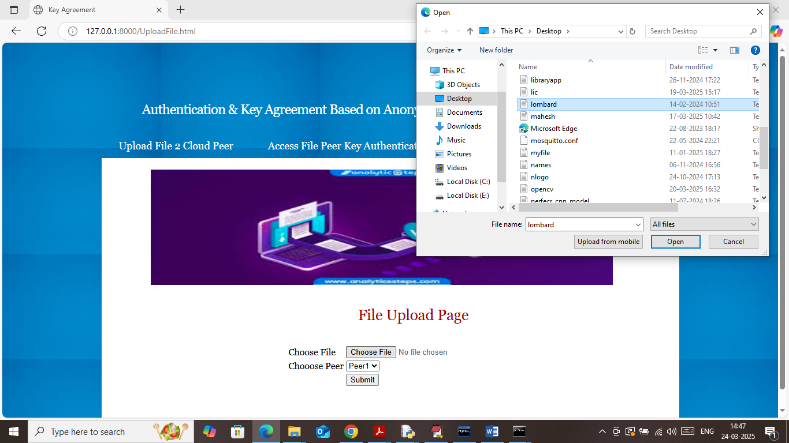

In above screen selecting and uploading sample file and then click on ‘Open’ button to load file and then choose desired PEER to save that file and then will get below page

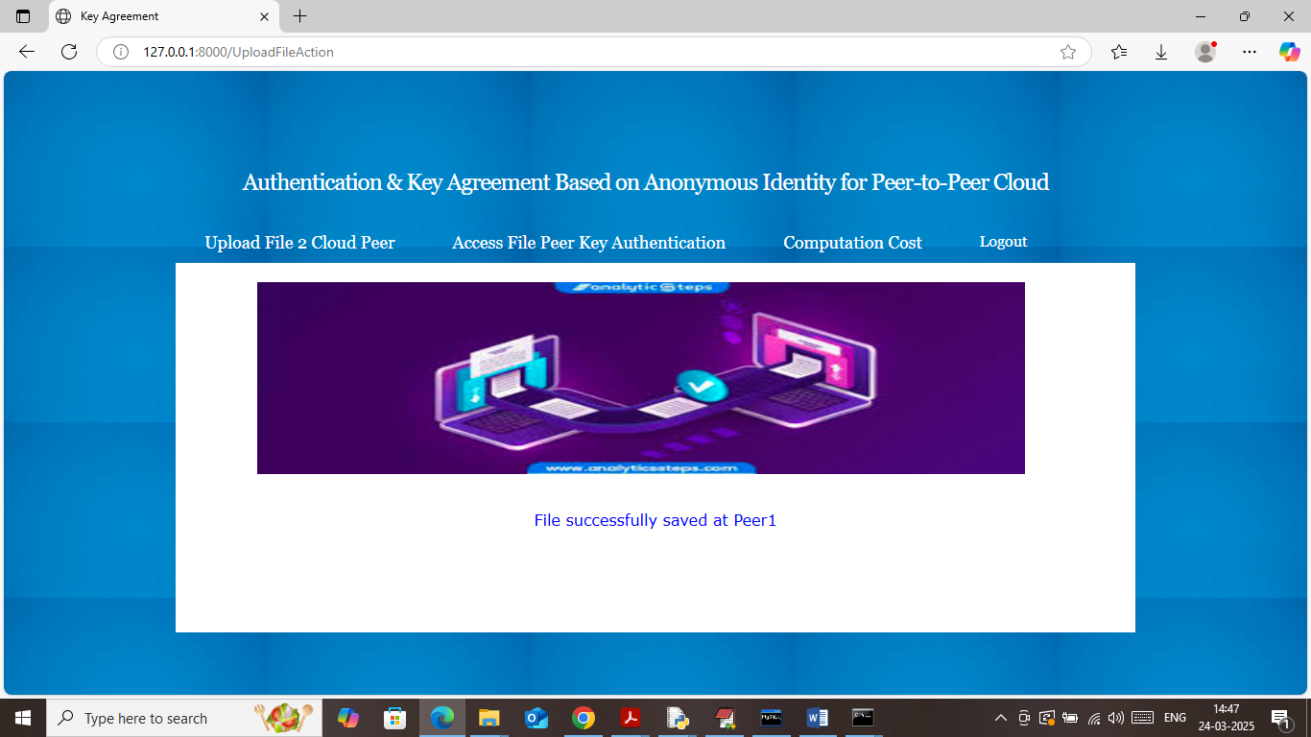

In above screen File saved at ‘Peer1’ and similarly you can upload any number of files. Now will try to access this file from Peer2 as this peer don’t have this file so it will securely authenticate with Peer1 to get file exchange and then serve to user. To access file click on ‘Access File Peer Key Authentication’ link to get below page

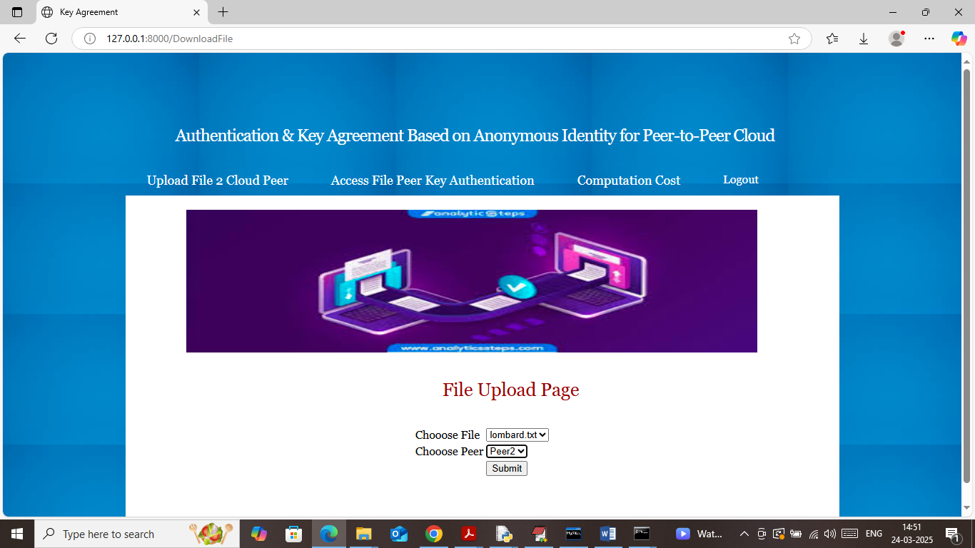

In above screen I am trying to download selected file from Peer2 and this peer don’t have file so it will connect to peer1 by anonymous authentication and then exchange file and then will get below output

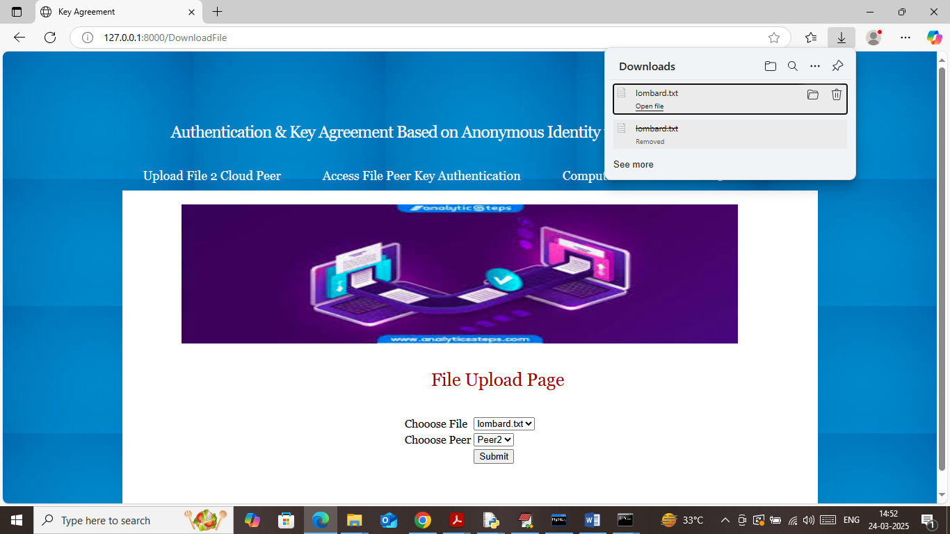

In above screen in browser task bar can see file successfully downloaded and similarly you can download any number of files from any peer. Now click on ‘Computation Cost’ link to get below page

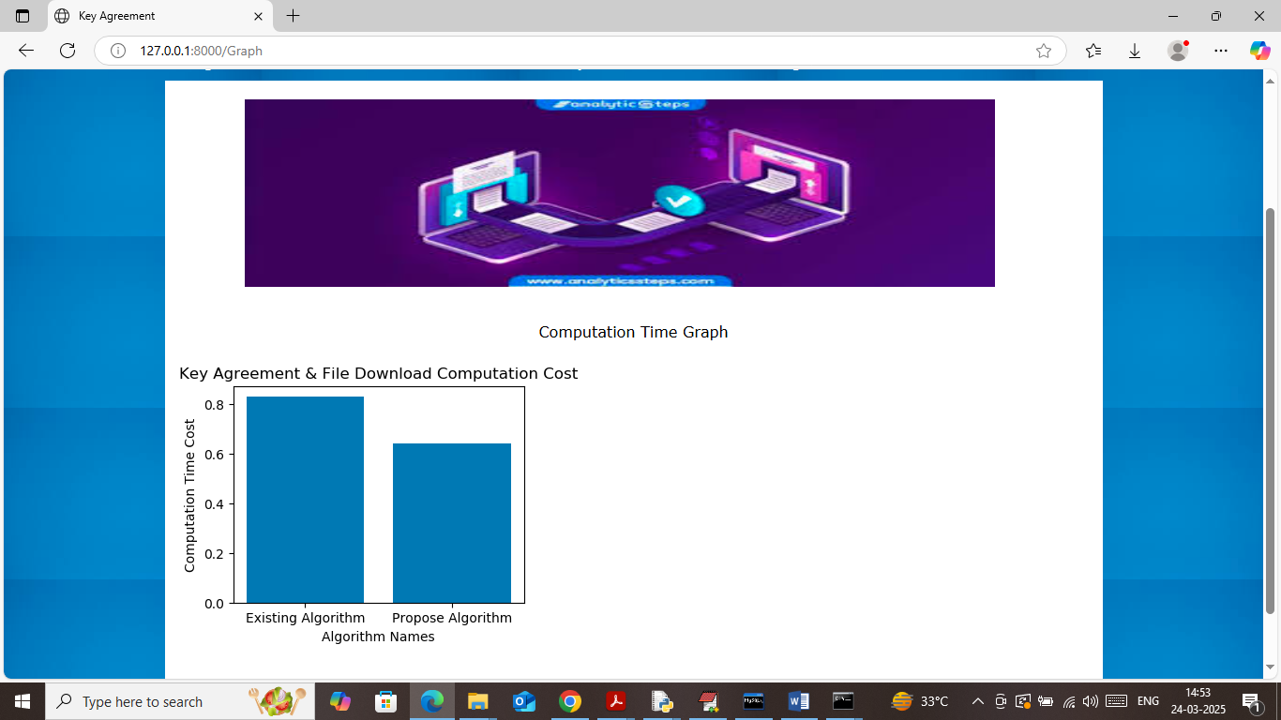

In above graph x-axis represents technique names and y-axis represents file download and key exchange and authentication time. In above graph propose technique using P2P system so its computation will be less as multiple peers search files in its own memory.

In below screen can see P2P log files

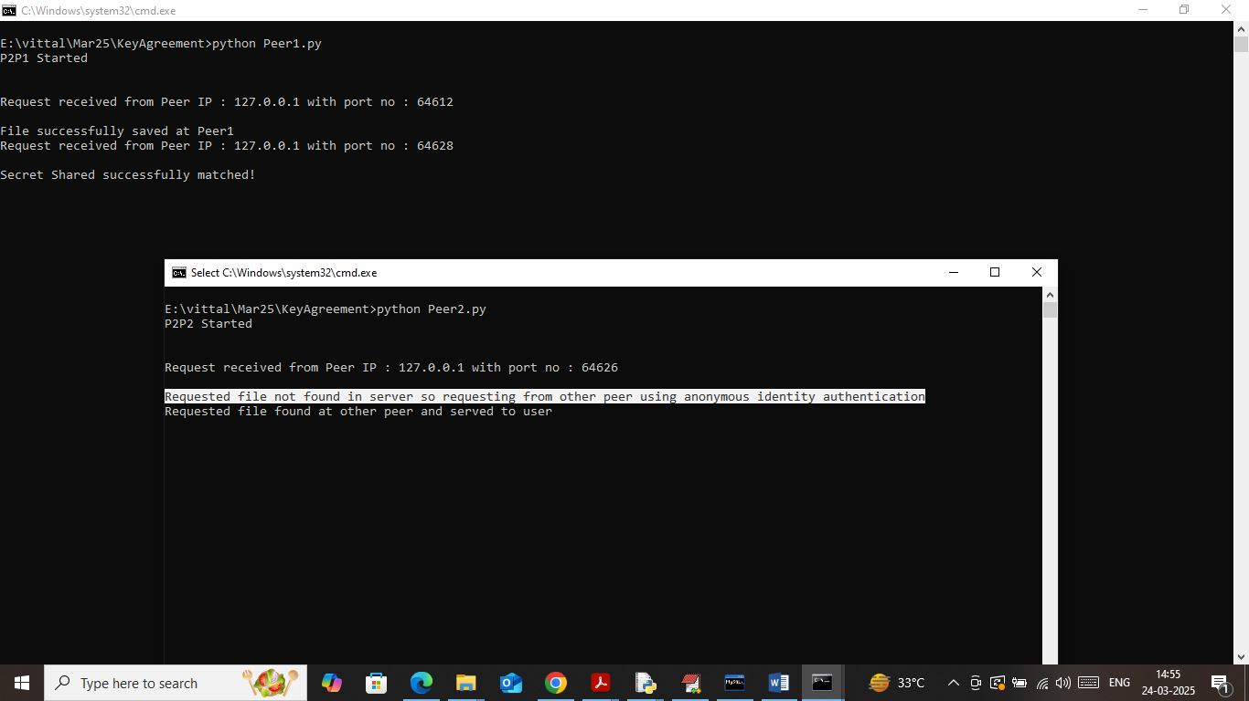

In above screen in white text at Peer2 it won’t find file so it send request to Peer1 which authenticate secret share and upon successful secret share match, it send file to peer2.

Note: we don’t have any real p2p networks or cloud servers so we designed above dummy socket based P2P system with secret share key exchange authentication.

**Conclusion:**

In this project, we have presented a novel authentication and key agreement protocol designed specifically for peer-to-peer cloud environments, with a strong emphasis on preserving user anonymity. By leveraging anonymous identities and elliptic curve cryptography, the system effectively addresses the challenges of user privacy, mutual authentication, and secure communication without depending on centralized authorities. This decentralized approach enhances the resilience and scalability of P2P clouds, making it well-suited for dynamic and distributed network scenarios.

The proposed protocol successfully mitigates common security threats such as replay attacks, impersonation, and man-in-the-middle attacks while maintaining a lightweight and efficient design. This ensures that even resource-constrained peer devices can perform secure authentication and key exchanges with minimal computational overhead. Furthermore, the system supports seamless peer joining and leaving, preserving the security and anonymity of all participants throughout the network’s lifecycle.

Overall, the implementation demonstrates that it is possible to balance anonymity, security, and performance in peer-to-peer cloud networks. This solution not only protects user identities but also establishes a trustworthy communication environment essential for decentralized cloud computing. The findings from this project lay a strong foundation for future research and development in secure, privacy-preserving protocols for distributed cloud infrastructures.

**Future Work:**

Future enhancements of this system can explore integrating multi-factor authentication methods to further strengthen security without compromising user anonymity. Combining biometric verification or device-based authentication with anonymous identity protocols could provide an additional layer of protection against unauthorized access.

Another promising direction is the integration of blockchain technology to decentralize trust management even further. Using blockchain can enable immutable and transparent identity management, secure key distribution, and auditability without exposing user identities, thereby enhancing both security and privacy in P2P cloud networks.

Additionally, optimizing the protocol for emerging technologies such as edge computing and the Internet of Things (IoT) will broaden its applicability. Lightweight and scalable anonymous authentication mechanisms are essential for these environments where devices often have limited resources and require fast, secure interactions.

Lastly, exploring adaptive security measures based on real-time network threat detection can help the system dynamically adjust authentication and key agreement protocols. This will improve resilience against evolving cyber-attacks and enhance the overall robustness of peer-to-peer cloud infrastructures.

**References**

1. **Zhang, Y., & Fang, Y.** (2011). "An Efficient Anonymous Authentication Protocol for Wireless Sensor Networks." IEEE Transactions on Wireless Communications, 10(3), 790-799.  
   This paper discusses lightweight anonymous authentication protocols suitable for resource-constrained networks.
2. **Sun, H., Zhang, Y., & Fang, Y.** (2010). "A Secure and Efficient Anonymous Authentication Scheme for Vehicular Ad Hoc Networks." IEEE Transactions on Vehicular Technology, 59(7), 3405-3415.  
   Presents an anonymous authentication scheme ensuring privacy in dynamic vehicular networks.
3. **Wang, C., Cao, Z., & Li, J.** (2018). "A Survey on Anonymous Authentication Protocols in Cloud Computing." Journal of Network and Computer Applications, 103, 134-145.  
   Provides an overview of various anonymous authentication techniques applied in cloud environments.
4. **Al-Riyami, S. S., & Paterson, K. G.** (2003). "Certificateless Public Key Cryptography." Advances in Cryptology — ASIACRYPT 2003, LNCS 2894, 452-473.  
   Introduces certificateless cryptography useful for reducing certificate management overhead.
5. **Menezes, A., van Oorschot, P., & Vanstone, S.** (1996). Handbook of Applied Cryptography. CRC Press.  
   A foundational text covering cryptographic algorithms including elliptic curve cryptography.
6. **Li, F., & Hadjieleftheriou, M.** (2015). "Privacy-Preserving Authentication Protocols for Peer-to-Peer Networks." IEEE Transactions on Information Forensics and Security, 10(8), 1681-1694.  
   Explores privacy-focused authentication mechanisms tailored for P2P networks.
7. **Deng, R. H., & Liu, J. K.** (2012). "Identity-Based Authentication and Key Agreement in Peer-to-Peer Systems." Proceedings of the IEEE International Conference on Distributed Computing Systems, 642-649.  
   Details identity-based schemes for authentication in distributed P2P environments.
8. **Krawczyk, H.** (2005). "HMQV: A High-Performance Secure Diffie-Hellman Protocol." Advances in Cryptology – CRYPTO 2005, LNCS 3621, 546-566.  
   Describes an efficient authenticated key agreement protocol.
9. **Ren, K., Lou, W., & Zhang, Y.** (2016). "Design and Analysis of Anonymous Communication Protocols for Decentralized Networks." IEEE Transactions on Parallel and Distributed Systems, 27(8), 2351-2362.  
   Discusses protocols that ensure anonymity in decentralized communication systems.
10. **Wang, Q., & Jin, H.** (2019). "Lightweight Anonymous Authentication for the Internet of Things." Sensors, 19(9), 2034.  
    Focuses on lightweight authentication suitable for IoT devices, which shares similarities with P2P cloud challenges.